**LAB # 07**

**INTRODUCTION TO MATLAB**



**Spring 2024**

**CSE-301L**

**Operating System Lab**

Submitted by: **NAVEED AHMAD**

Registration No.: **22PWCSE2165**

Class Section: **B**

“On my honor, as student of University of Engineering and Technology, I have neither given nor received unauthorized assistance on this academic work.”

Submitted to:

**Dr. Safdar Nawaz Khan Marwat**

05/05/2024.

Department of Computer Systems Engineering

University of Engineering and Technology, Peshawar

**TASK 01:**

Using ones function, plot the signum sequence over interval ‐ 10 ≤ n ≤ 10. It can be defined as:



**CODE:**

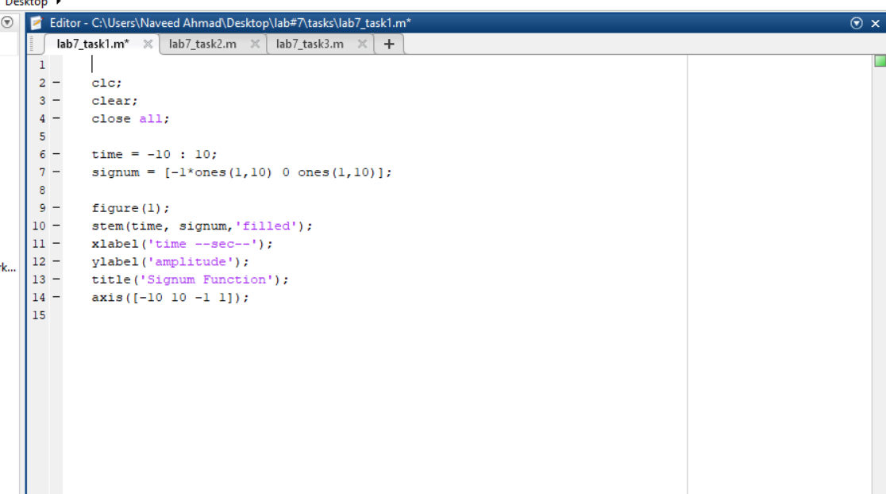

**OUTPUT:**

**TASK 02:**

Prove the following:

δ[n] = u[n] − u[n − 1]

**CODE:**

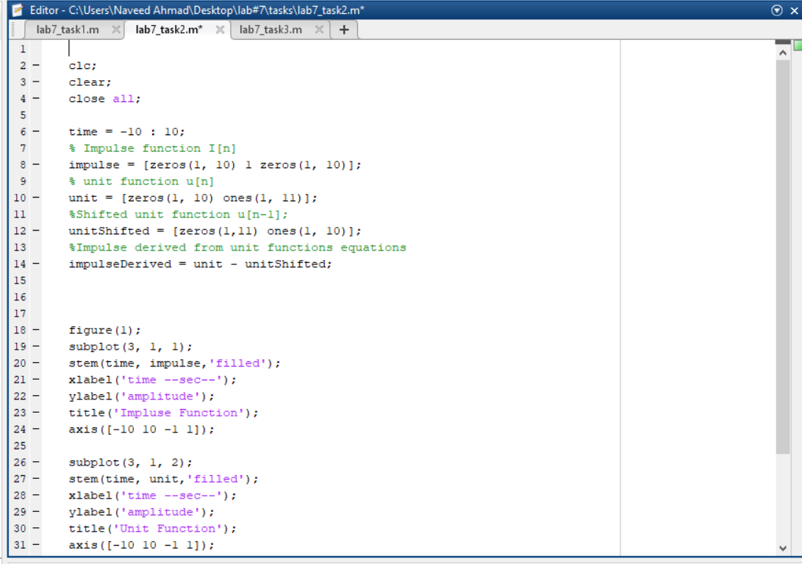

**OUTPUT:**

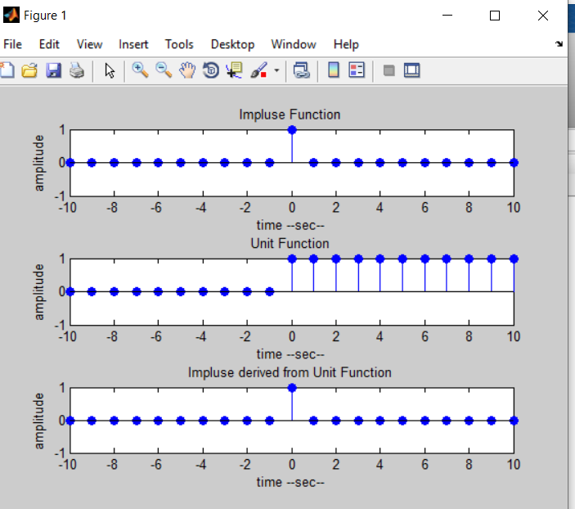

**TASK 03:**

Delay the original signal given in section 7.3.1 by 1 sec. Plot both the delayed and original signal in the same figure.

**CODE**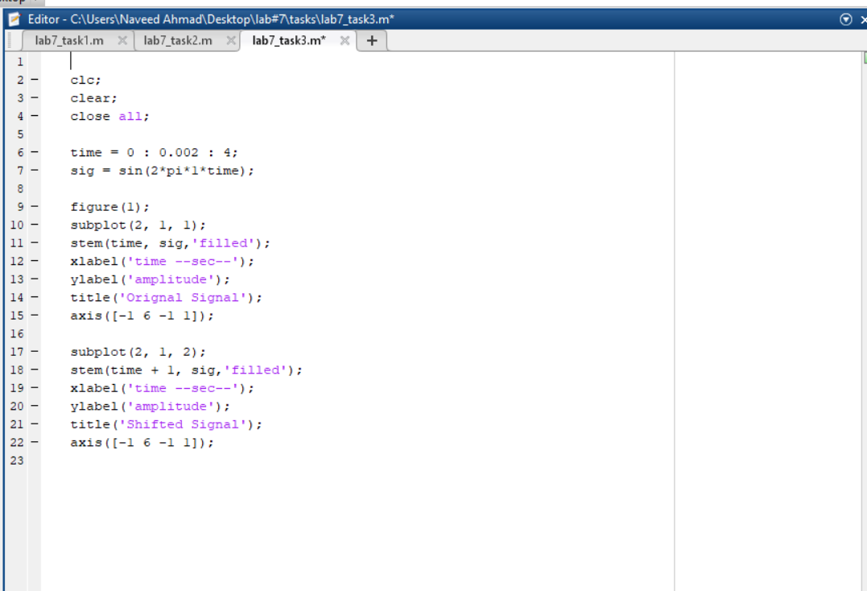

**OUTPUT:**

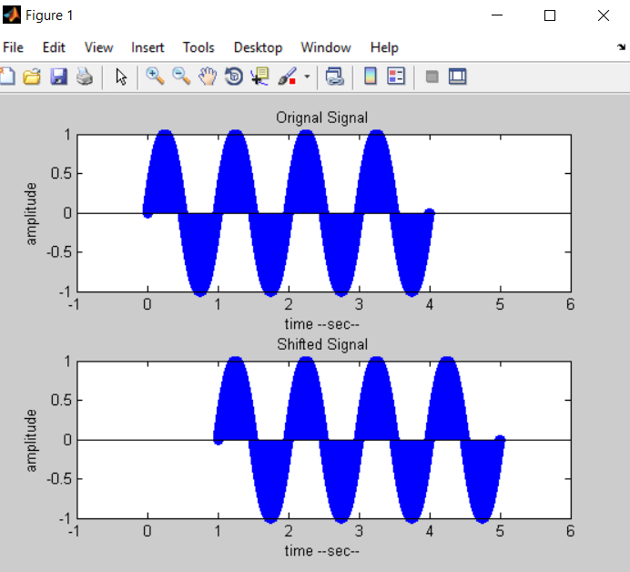

**TASK 04:**

Flip the following signal:



Plot the original signal as well as the flipped one in the same figure.

**CODE:**

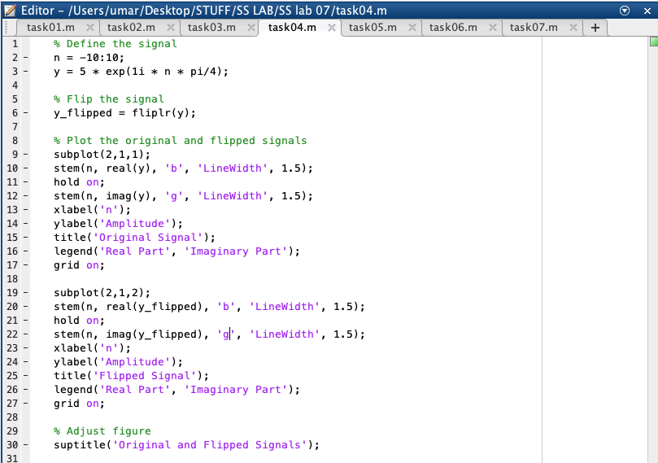

**OUTPUT:**

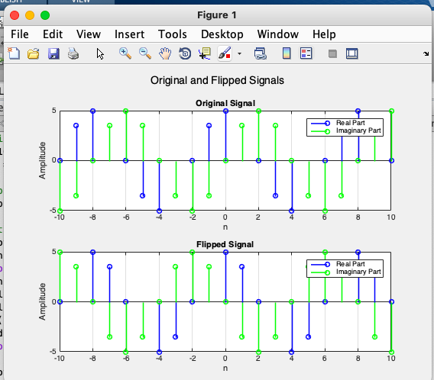

**TASK 05:**

Flip the following signal:

x[n] = 2δ[n] + 5δ[n‐ 1] + 8δ[n‐ 2] + 4δ[n‐ 3] + 3δ[n‐ 4]

Plot the original signal as well as the flipped one in the same figure.

**CODE:**

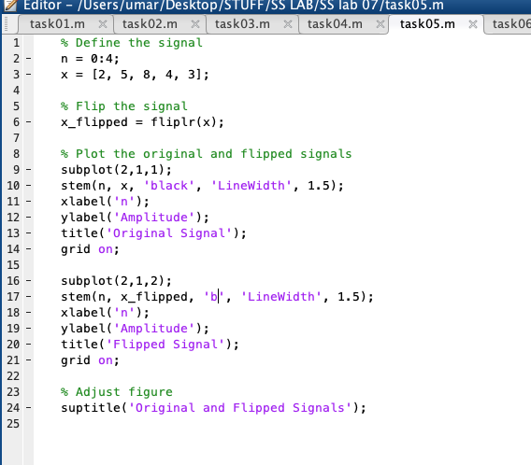

**OUTPUT:**

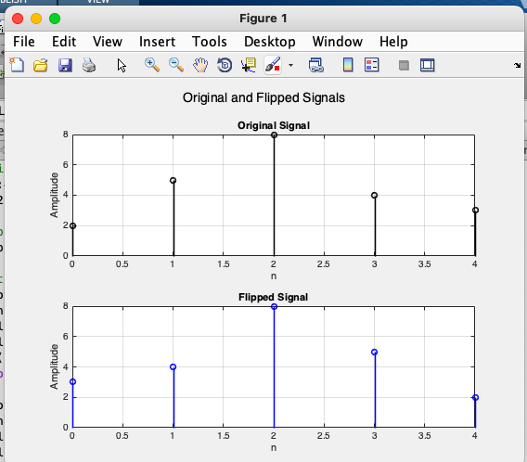

**TASK 06:**

Scale the continuous‐time sinusoid used in signal shifting example in section 7.3.1 by a factor of 2.

**CODE:**

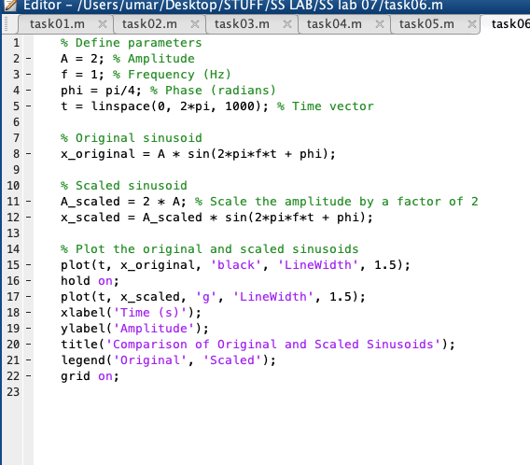

**OUTPUT:**

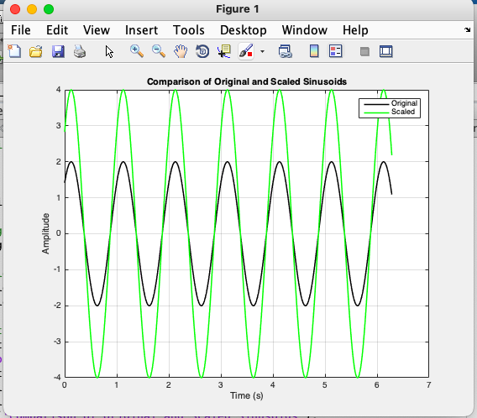

**TASK 07:**

Use interp command in the program in section 7.3.4 to interpolate (up‐sample) the signal by a factor of 2.

**CODE:**

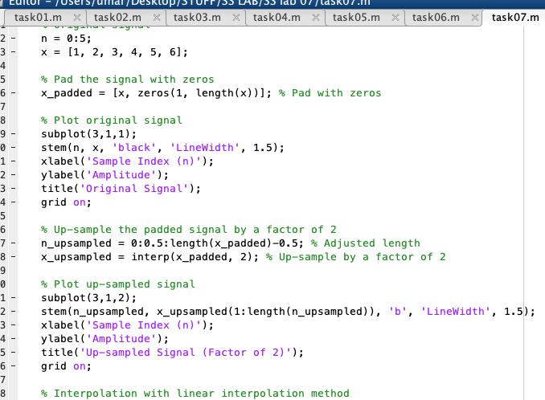

**OUTPUT:**

